SEC Form 3
FORM 3 | UNITED STATES SECURITIES AND EXCHANGE COMMISSION  Washington, D.C. 20549  INITIAL STATEMENT OF BENEFICIAL OWNERSHIP OF SECURITIES  Filed pursuant to Section 16(a) of the Securities Exchange Act of 1934  or Section 30(h) of the Investment Company Act of 1940
  OMB APPROVAL
  OMB Number: | 3235-0104
  Estimated average burden
  hours per response: | 0.5
1. Name and Address of Reporting Person*  (Street) | 2. Date of Event Requiring Statement (Month/Day/Year)  07/01/2026 | 3. Issuer Name and Ticker or Trading Symbol  MASTEC INC [ MTZ ]
  Miranda Manuel Benito
  (Last) | (First) | (Middle)
  1111 LOUISIANA ST.
  SUITE 4600
  HOUSTON | TX | 77002
  (City) | (State) | (Zip)
 |  | 4. Relationship of Reporting Person(s) to Issuer  (Check all applicable) | 5. If Amendment, Date of Original Filed (Month/Day/Year)
   | Director |  | 10% Owner
   | Officer (give title below) |  | Other (specify below)
6. Individual or Joint/Group Filing (Check Applicable Line)
Form filed by One Reporting Person
Form filed by More than One Reporting Person

Table I - Non-Derivative Securities Beneficially Owned
1. Title of Security (Instr. 4) | 2. Amount of Securities Beneficially Owned (Instr. 4) | 3. Ownership Form: Direct (D) or Indirect (I) (Instr. 5) | 4. Nature of Indirect Beneficial Ownership (Instr. 5)
Table II - Derivative Securities Beneficially Owned
(e.g., puts, calls, warrants, options, convertible securities)
1. Title of Derivative Security (Instr. 4) | 2. Date Exercisable and Expiration Date (Month/Day/Year) |  | 3. Title and Amount of Securities Underlying Derivative Security (Instr. 4) |  | 4. Conversion or Exercise Price of Derivative Security | 5. Ownership Form: Direct (D) or Indirect (I) (Instr. 5) | 6. Nature of Indirect Beneficial Ownership (Instr. 5)
1. Title of Derivative Security (Instr. 4) | Date Exercisable | Expiration Date | Title | Amount or Number of Shares | 4. Conversion or Exercise Price of Derivative Security | 5. Ownership Form: Direct (D) or Indirect (I) (Instr. 5) | 6. Nature of Indirect Beneficial Ownership (Instr. 5)
Explanation of Responses:
Remarks:
EXHIBIT LIST: Exhibit 24 - Power of Attorney
No securities are beneficially owned.
 | \s\ Alberto de Cardenas For: Manuel Benito Miranda | 07/10/2026
 | ** Signature of Reporting Person | Date
Reminder: Report on a separate line for each class of securities beneficially owned directly or indirectly.
* If the form is filed by more than one reporting person, see Instruction 5 (b)(v).
** Intentional misstatements or omissions of facts constitute Federal Criminal Violations See 18 U.S.C. 1001 and 15 U.S.C. 78ff(a).
Note: File three copies of this Form, one of which must be manually signed. If space is insufficient, see Instruction 6 for procedure.
Persons who respond to the collection of information contained in this form are not required to respond unless the form displays a currently valid OMB Number.
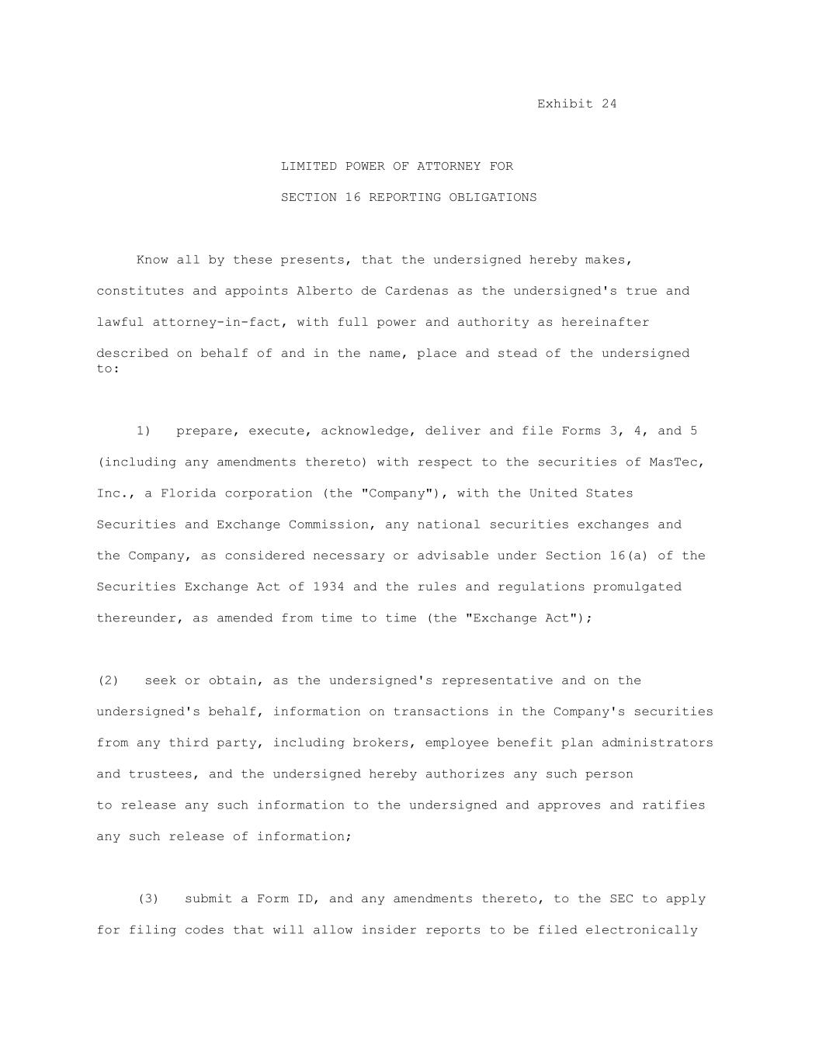
Exhibit 24 LIMITED POWER OF ATTORNEY FOR SECTION 16 REPORTING OBLIGATIONS Know all by these presents, that the undersigned hereby makes, constitutes and appoints Alberto de Cardenas as the undersigned's true and lawful attorney-in-fact, with full power and authority as hereinafter described on behalf of and in the name, place and stead of the undersigned to: 1) prepare, execute, acknowledge, deliver and file Forms 3, 4, and 5 (including any amendments thereto) with respect to the securities of MasTec, Inc., a Florida corporation (the "Company"), with the United States Securities and Exchange Commission, any national securities exchanges and the Company, as considered necessary or advisable under Section 16(a) of the Securities Exchange Act of 1934 and the rules and regulations promulgated thereunder, as amended from time to time (the "Exchange Act"); (2) seek or obtain, as the undersigned's representative and on the undersigned's behalf, information on transactions in the Company's securities from any third party, including brokers, employee benefit plan administrators and trustees, and the undersigned hereby authorizes any such person to release any such information to the undersigned and approves and ratifies any such release of information; (3) submit a Form ID, and any amendments thereto, to the SEC to apply for filing codes that will allow insider reports to be filed electronically

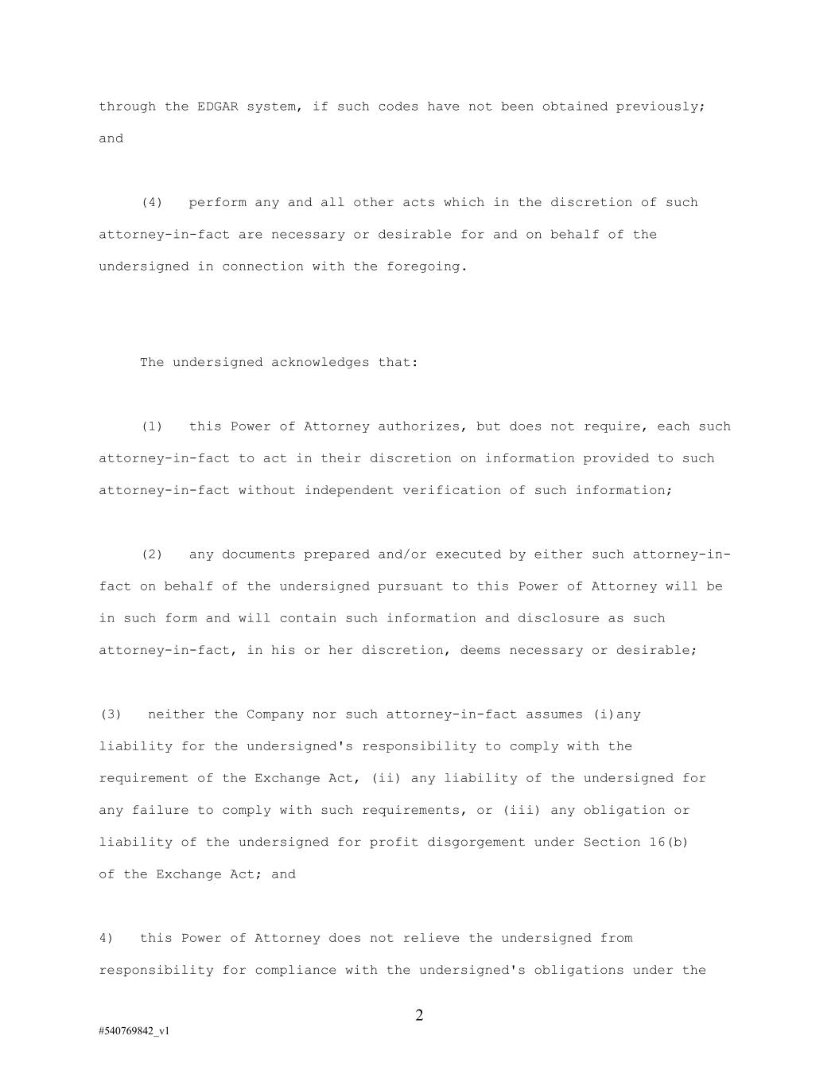
2 #540769842_v1 through the EDGAR system, if such codes have not been obtained previously; and (4) perform any and all other acts which in the discretion of such attorney-in-fact are necessary or desirable for and on behalf of the undersigned in connection with the foregoing. The undersigned acknowledges that: (1) this Power of Attorney authorizes, but does not require, each such attorney-in-fact to act in their discretion on information provided to such attorney-in-fact without independent verification of such information; (2) any documents prepared and/or executed by either such attorney-in- fact on behalf of the undersigned pursuant to this Power of Attorney will be in such form and will contain such information and disclosure as such attorney-in-fact, in his or her discretion, deems necessary or desirable; (3) neither the Company nor such attorney-in-fact assumes (i)any liability for the undersigned's responsibility to comply with the requirement of the Exchange Act, (ii) any liability of the undersigned for any failure to comply with such requirements, or (iii) any obligation or liability of the undersigned for profit disgorgement under Section 16(b) of the Exchange Act; and 4) this Power of Attorney does not relieve the undersigned from responsibility for compliance with the undersigned's obligations under the

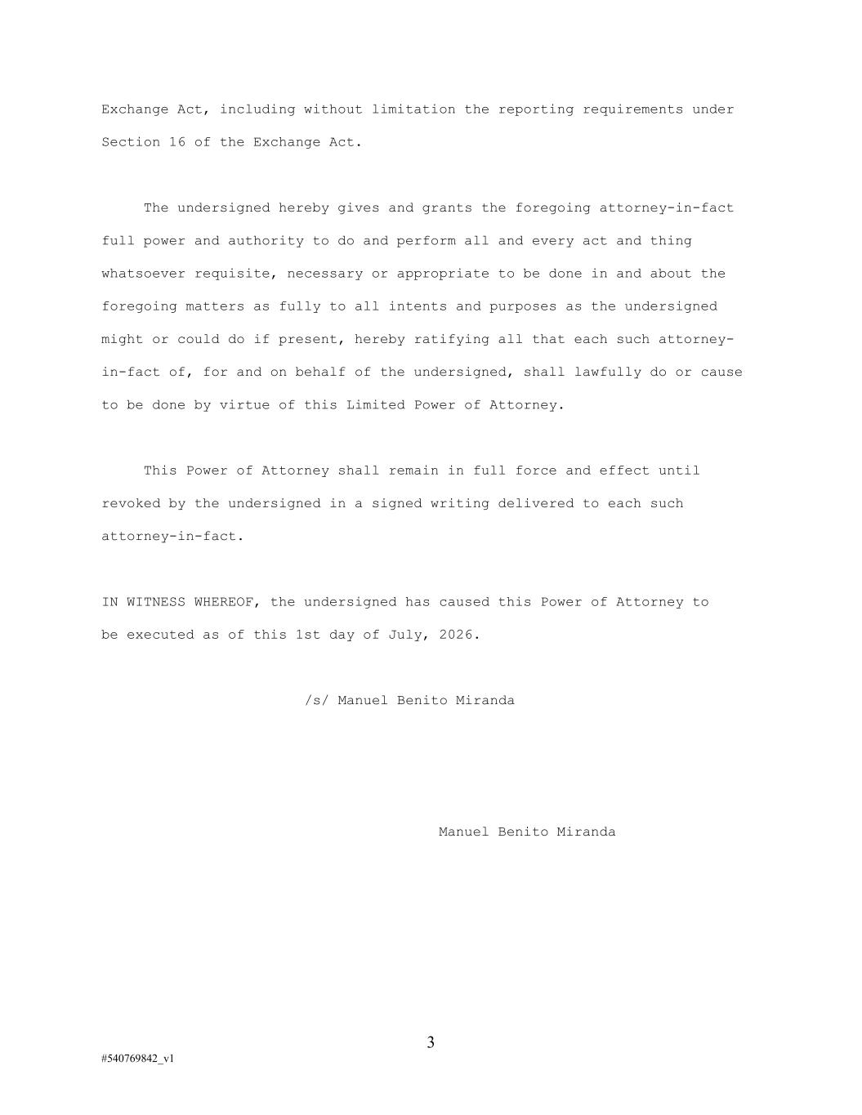
3 #540769842_v1 Exchange Act, including without limitation the reporting requirements under Section 16 of the Exchange Act. The undersigned hereby gives and grants the foregoing attorney-in-fact full power and authority to do and perform all and every act and thing whatsoever requisite, necessary or appropriate to be done in and about the foregoing matters as fully to all intents and purposes as the undersigned might or could do if present, hereby ratifying all that each such attorney- in-fact of, for and on behalf of the undersigned, shall lawfully do or cause to be done by virtue of this Limited Power of Attorney. This Power of Attorney shall remain in full force and effect until revoked by the undersigned in a signed writing delivered to each such attorney-in-fact. IN WITNESS WHEREOF, the undersigned has caused this Power of Attorney to be executed as of this 1st day of July, 2026. /s/ Manuel Benito Miranda Manuel Benito Miranda

